**LESSON PLAN**

|  |  |  |  |  |  |
| --- | --- | --- | --- | --- | --- |
|  | | | **School**: Talapker secondary school | | |
| **Date:12.09.2023** | | | **Teacher name: Shrakhmetova Zh.T, Akhmetova G.D** | | |
| **CLASS:9** | | | **Number present:** | **absent:-** | |
| **Theme of the lesson: Famous people of Kazakhstan** | | | | | |
| **Learning objectives(s)**  **that this lesson is**  **contributing to** | | *generalization and extension of students' knowledge of the greatest figures of the Kazakh culture and their contribution to the development of world literature.* | | | |
| **Lesson objectives** | | **Learners will be able to:**  *- Improve lexical and grammatical, the pronunciation, auditive skills, reading, speaking and writing in the multilingualism;*  *-. Develop cognitive processes (attention, visual and auditory memory, logical and linguistic thinking, imagination), formation of the ability to analyze, synthesize, compare and summarize the lexical and grammatical phenomena in speech and writing;*  *- The exercise of spiritual and moral and aesthetic education of schoolchildren (nurture patriotism, love for the mother tongue, state and English languages, the sense of beauty, to form civic position of pupils* | | | |
| **Assessment criteria:** | | * ***Learners achieve this Learning objective, if they*** * *-can follow supported* *classroom instructions* * *-can practice the specific vocabulary to talk about the short texts* * *-can complete**with support a sequence of short sentences* | | | |
| **Value links:** | | *The Patriotic Act ’Mangilik Yel’: Universal Labor Society* | | | |
| **Cross-curricular links:** | | *History, Literature* | | | |
| **ICT skills:** | | *Interactive board to show famous Kazakh artists of Kazakhstan, whiteboard, pictuers* | | | |
| **Previous learning:** | | *Learners know about famous Kazakh artists of Kazakhstan*  *Learners express own ideas* | | | |
| **PLAN** | | | | | |
| Planned timings | **Planned activities** | | | | **Resources** |
| **Start**  5 min  **5 min**  Middle  10 min  **10 min**  **5 min**  **3 min**  End  2 min | **Organization moment**  ***Stages of the lesson:***  ***1. Organizational moment. (****Greeting duty dialogue, introduction to the topic of the lesson, the message of his goals and objectives).*  *- Good afternoon, pupils! ...*  *- What season is it now? What month is it now?*    *- I want to begin our lesson with the proverb:*  *Өнер – ағып жатқан бұлақ,  Білім – жанып жатқан шырақ.  Art - running spring,*  *Education - a burning candle.*  *As you know, our life is impossible without water and light, but it is impossible to live without knowledge and arts too. Now, please, tell me, who can give us an opportunity to use such “sources” of life? - Writers and poets. What kind of famous people of Kazakhstan do you know?* ***The theme of our lesson is: Famous people of Kazakhstan*** *Today at the lesson we shall speak about the greatest Kazakh famous people, such as Abai Kunanbaev, Ibrai Altynsarin and Muhtar Auezov, their biographies and creative works. We shall practise in making up short reports about them.*  ***3. Repetition of lexical material.***  *Let’s revise the most useful words according to the theme of the lesson in Kazakh and English. Translate the words from Kazakh into English:*  ***көрнекті outstanding***  ***aтақты famous***  ***ойшыл thinker***  ***ағартушы educator***  ***аудармашы translator***  ***негізін қалаушы the founder***  ***сазгер composer***  ***өлеңдер poems***  ***білім education***  ***ұрпақ generation***  ***ғылым science***  ***ақын poet***  ***жазушы writer***  ***мұғалім teacher***  ***мәдениетті cultural***  ***салт-дәстүрлері customs and traditions***  ***шетел тілі foreign language***  ***ана тілі mother tongue***  *Ok I’ll give 3 texts for each group. Please read the texts and work with group, please. Then works with cards. During the listening to the reports you have to fill in the chart given below:*  ***Abai Kunanbaev, Ibrai Altynsarin, Muhtar Auezov***  1 Name  2 Occupation  3 Date / place of birth  4 Education  5 The most famous creative works  6 Public activity  7 Monuments  Date of death  ***4. Work with text.***  *There are 3 individual cards, containing the information about Abai Kunanbaev, Ibrai Altynsarin and Muhtar Auezov. The 1st task is to choose the necessary words explaining their occupation. The 2nd task is to read the statements, choose 5 necessary sentences to tell about the famous person and to put them in the correct order. Then change the cards to check them up.*  *Ibrai Altynsarin is a ...*  • writer  • builder  • public figure  • innovator  • translator  • teacher  • ambassador  • worker  • student  • professor  • inventor  • actor  • philosopher  • thinker  • composer  • enlightener  • engineer    *Read the statements, choose 5 necessary sentences to tell about Ibrai Altynsarin and put them in the correct order:*  *• He learnt the works of the worldwide writers and poets, such as Shakespeare, Byron, Pushkin, Gogol, Lermontov, Ferdausi, Nizami.*  *• He finished the muslim religious school (medresse). Also he studied at Russian school and started writing poems there.*  *• In 1860 he opened the specialized school for Kazakh children (for girls) to teach them the Russian language.*  *• Being influenced by his mother he was fond of books and poetry.*  *• His father died when he was very young, that’s why he was brought up by his grandfather.*  *• In 1928 he graduated from Leningrad University, where he studied at the faculty of History and Philology.*  *• He had been elabourating the New Kazakh Alphabet for 3 years.*  *• He was born in 1841 in Torgai Region.*  ***Abai Kunanbaev is a ...***  • poet  • writer  • builder  • public figure  • innovator  • translator  • teacher  • ambassador  • worker  • student  • professor  • inventor  • actor  • philosopher  • thinker  • composer  • enlightener  • founder    *Read the statements, choose 5 necessary sentences to tell about Abai Kunanbaev, put them in the correct order:*  *• He died in 1904.*  *• He died in 1961, his stories and novels became very popular among young people.*  *• He was born in 1845.*  *• Sometime later he was moved to the administrative department of Orynbor region as a translator.*  *• Being influenced by his mother he was fond of books and poetry.*  *• He had been elabourating the New Kazakh Alphabet for 3 years.*  *• He finished the muslim religious school (medresse). Also he studied at Russian school and started writing poems there.*  *• He translated many works of Pushkin, Lermontov, Gothe, Tolstoi, Saltykov – Schedrin and other poets and writers from Russian into Kazakh.*  *• In 1928 he graduated from Leningrad University, where he studied at the faculty of History and Philology.*  *• His first work “Enlik-Kebek” was written in 1917, it was the beginning of the great creative way.*  ***Muhtar Auezov is a ...***  • poet  • writer  • builder  • public figure  • innovator  • translator  • teacher  • ambassador  • worker  • student  • professor  • inventor  • actor  • philosopher  • thinker  • composer  • enlightener  • scientist  *Read the statements, choose 5 necessary sentences to tell about Muhtar Auezov, put them in the correct order:*  *• His first work “Enlik-Kebek” was written in 1917.*  *• He had been elabourating the New Kazakh Alphabet for 3 years.*  *• He died in 1961; his stories and novels became very popular among young people.*  *• He learnt the works of the worldwide writers and poets, such as Shakespeare, Byron, Pushkin, Gogol, Lermontov, Ferdausi, Nizami.*  *• In 1928 he graduated from Leningrad University, where he studied at the faculty of History and Philology.*  *• Being influenced by his mother he was fond of books and poetry.*  *• He was born in 1897 in Semey region.*  *• He finished the Muslim religious school (medresse).*  *• He had written a great number of famous stories and novels, interesting* *articles and books, which represent one of the most important directions in Kazakh written literature.*  *5. Test yourself:*  *1. He was born in 1841 in Torgai Region.*  *2. His father died when he was very young, that’s why he was brought up by his grandfather.*  *3. He learnt the works of the worldwide writers and poets, such as Shakespeare, Byron, Pushkin, Gogol, Lermontov, Ferdausi, Nizami.*  *4. In 1860 he opened the specialized school for Kazakh children (for girls) to teach them the Russian language.*  *5. He had been elabourating the New Kazakh Alphabet for 3 years.*  *1. He was born in 1845.*  *2. He finished the muslim religious school (medresse). Also he studied at Russian school and started writing poems there.*  *3. Being influenced by his mother he was fond of books and poetry.*  *4. He translated many works of Pushkin, Lermontov, Gothe, Tolstoi, Saltykov – Schedrin and other poets and writers from Russian into Kazakh.*  *5. He died in 1904.*  *1. He was born in 1897 in Semey region.*  *2. His first work “Enlik-Kebek” was written in 1917.*  *3. In 1928 he graduated from Leningrad University, where he studied at the faculty of History and Philology.*  *4. He had written a great number of famous stories and novels, interesting articles and books, which represent one of the most important directions in Kazakh written literature.*  *5. He died in 1961, his stories and novels became very popular among young people.*  ***6. Conclusion***  *You must remember that Abai Kunanbaev, Ibrai Altynsarin and Muhtar Auezov are really outstanding persons; their creative works teach us to be patriotic, generous, hardworking, brave, patient, devoted to friendship and family relations, purposeful.*  ***Thank you for the lesson! Good-bye!*** | | | | A sheet of paper  PPP slide-1  Active board,  PPP slide 2  Pictures  PPP slide – 3  PPP slide 4  PPP slide 5 |

**Талапкер ауылының жалпы орта білім беретін мектебі**

***Theme:*** *“Famous people of Kazakhstan”*

***Done by: Akhmetova G.D***

***Shrakhmetova Zh.T***

**2023-2024 school year**

**Талапкер ауылының ЖОББ мектебінде "Тіл өлшеусіз қазына өрісі кең әлем" атты тілдер апталығына орай ұйымдастырылған іс шарада ағылшын тілінен "Famous people of Kazakhstan" тақырыбында өткен сыныптан тыс сабақтың ақпараты**

**Күні:**12.09.2023

**Тақырыбы: «Famous people of Kazakhstan»**

**Сынып: 9 сыныптар**

**Мақсаты:** 9-сынып оқушылары арасында сөйлеу дағдыларын дамыту мақсатында Қазақ халқының улы адамдары жайында өз ойларын айту, дәйекпен, дәлелді көрсетуге тәрбиелеу. Тілді құрметтеуге үйрету.

12.09.2023 күні « Қазақ халқының ұлы адамдары» такырыбында 9-сыныптар арасында сыныптан тыс сабақ өткізілді. Сабақ барысында оқушылар 3 топқа бөлінді. Қазақ ақын-жазушылары жайында викториналық сұрақтар, мәтінмен жұмыс, аударма тапсырмалары да берілді. Әр топ оқушылары сабаққа өте қызығушылықпен қатысты деуге болады.

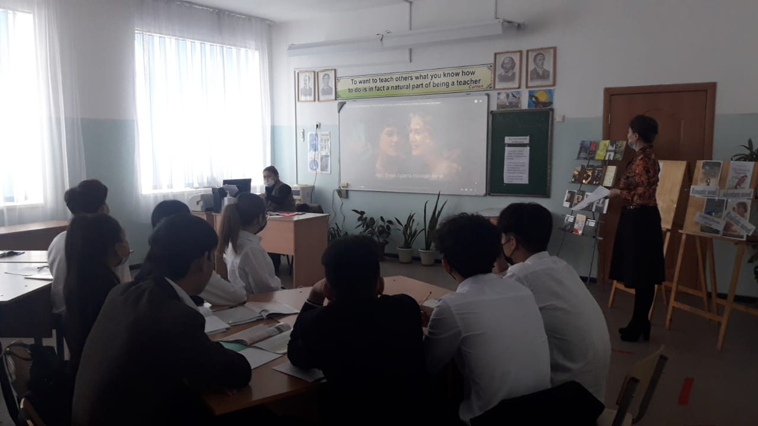 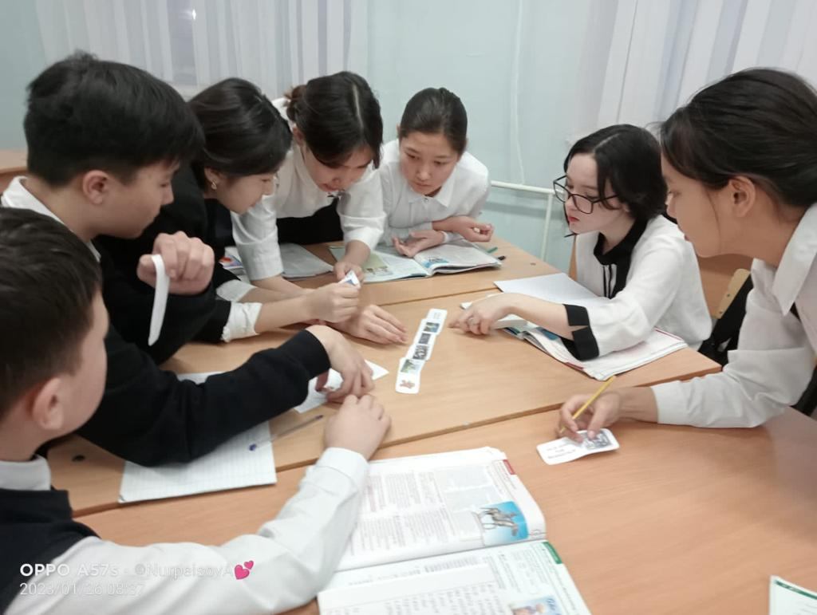

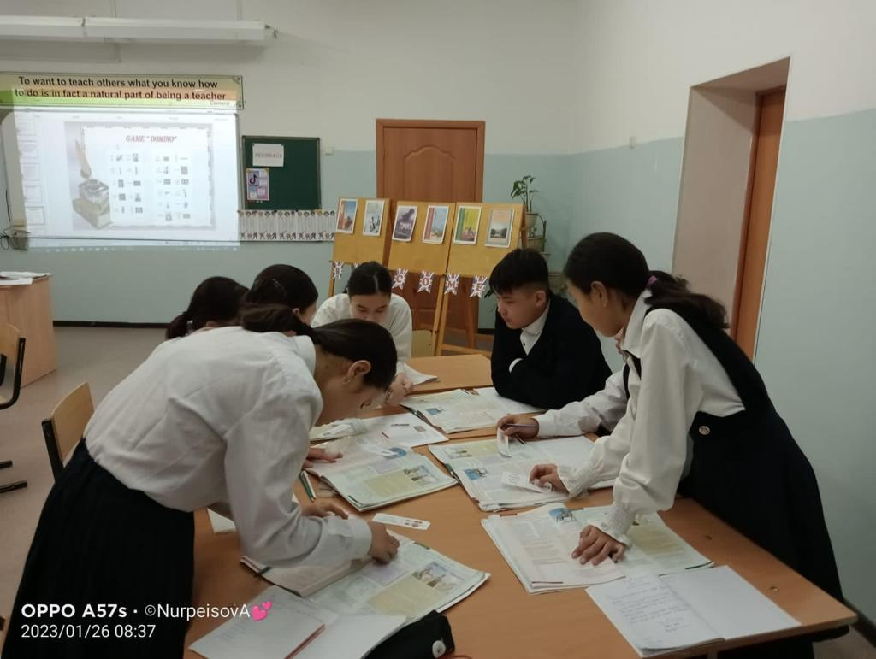

**Пән мұғалімі: Шрахметова Ж.Т**

**Ахметова Г.Д**